**Unsupervised Learning**

**-Definition**

* We don’t teach the model or load it with info. i.e We don’t provide it with labeled

dataset.

* The model works on its own to discover info that may not be visible to humans, i.e. we use algorithms that draw conclusions on unlabeled data
* It’s more difficult than supervised:

Little to know info about the data and the expected output.

* It has fewer tests and models that can be used to ensure that the outcome of the model is accurate => Less controllable environment as the machine is creating outcomes for us.
* This model relies on Clustering: Analysis of patterns and groupings of unlabeled data. We don’t interfere when the algorithm is learning

**Example**: Watching a match of a sport you don’t know with your friend without them teaching you anything

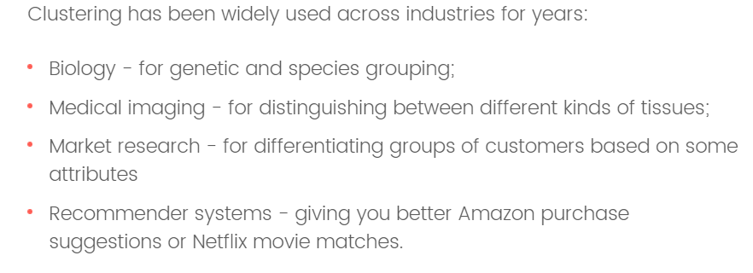

-**Association rule (Apriori Algorith):**

Supermarket example

Relationships of products(items) in different sets, and the frequency of association. Eliminating the association below a certain threshold. Or to find the one highest (Max.) association between products

Get frequent items or frequent item sets

